How to build public support to transform social care – research report

Background to this research report

Social Care Future (SCF) is a movement of people with a shared commitment to bringing about positive change in social care. The vision of SCF is to tell a new story and communicate a positive approach to social care based on well-being and individual needs. SCF wants to promote a vision which shifts the narrative of social care from being ‘for people’ to an approach that is more inclusive and self-directional. Its vision sees social care as being achieved ‘with people’ often in their own home and community rather than something that is done to them with little individual control. To help bring about change in line with the vision, SCF are applying a values-based framing approach to talking about social care.

Survation is a leading market research, polling and strategic communications company. Survation was commissioned to conduct this research, working closely with Equally Ours and SCF. This research provides an evidence-based approach to support a reframing and communication intervention plan, for persuasion audiences, so that social care is seen within a wider and community context. This research was conducted on behalf of Survation by Jane Carn, Madhur Mehra and Harry Mason.

SCF had identified a number of gaps between its vision for social care and the dominant framing prevalent in the media and amongst the general public. In order to shift the narrative around social care, the research firstly needed to test the hypothesis around the dominant framing around social care. Secondly, it sets out to provide guidance on how to bridge the gap between this view of social care and the story SCF wants to tell. As part of this process, the research involved developing and testing frames to explore which narrative, language and imagery will encourage a shift in understanding, so people think differently about social care and support investment in sustainable, community-based approach.

Outlined below is an example of the story SCF wishes to tell, and the dominant frame that exists about social care in the media and public domain.

The story we want to tell | The dominant framing today
People of equal worth leading  lives of value, that they choose to lead, as part of a reciprocal web of community-based support (mutuality) | Vulnerable people’ being looked after by regulated personal care services with ‘life and limb’ support delivered by care staff (paternalism)
Focused on people and communities benefiting from and contributing to great social care | Focused on the challenges faced by the ‘sector’ in delivering care as a service to people
Social care is a springboard | Social care is a safety net
People with gifts and potential | People with needs
We have great ideas for how to better support people to lead good lives, that require a reformed approach and financial investment | Social care is in crisis and is broken and funding to maintain the status quo is the only answer

This research had two clear objectives covered in this report:

1. Understand public attitudes providing clear and robust evidence about what the public thinks and feels about social care (in a broad sense)

2. Provide clear evidence on what frames and messages are most successful in shifting public thinking, including what language and metaphors work best to drive understanding of and support for #socialcarefuture’s vision and approach.

Summary of the research methodology
Survation used a mix of both qualitative and quantitative research to answer the research objectives. A summary of the research methods is outlined below.

Qualitative Research:
We conducted two stages of qualitative research to explore public perceptions and to feed into the development of narrative frames.
- Firstly, we conducted an online forum with 22 people over 5 days to explore their attitudes towards social care – focusing on the values and beliefs that underpinned their views.
- We then conducted a further stage of 4x online focus groups to test and develop the frames and messages.

All qualitative research was conducted with the ‘persuadable’ public – defined as those in the population who don’t have strong ideological views and are open to change. A number of different questions were used to define the persuadable public including voting behaviour, attitude statements and political perspective (excluding those who are extremely left or right leaning).

In terms of demographics, the qualitative research was conducted with a mix of people by age (30-75 years), gender and ethnicity, and included those in geographical locations including the “Red Wall” former Labour areas of the North West as well as the South and South East.

Quantitative Research:
Following the qualitative research, Survation carried out a large scale UK nationally representative survey of 3023 adults 18+ years. Data was weighted by age, gender, region and past vote in national elections (2019, 2017 GE and 2016 EU ref). The fieldwork was conducted between 4th and 10th December 2020.

The survey involved splitting people into 5 different identical groups who each saw a different combination of vision statement and message.

- We asked a series of questions upfront to the total sample including what words and statements participants associate with social care as well as whether social care should be a government priority in comparison to other things such the NHS, climate change or cutting taxes for business.
- We divided our sample into 5 subgroups, each subgroup was shown a combination of metaphors/ messages and vision statements.
- After participants had seen the messages and statements, participants were asked again what words and statements they most associated with social care.
- By comparing the ‘before’ and ‘after’ results we can see how our messages shifted people’s opinions about social care.

Understanding the current story

Social care is about ‘vulnerable’ people

Qualitative Feedback

Through our qualitative research we identified that as the term social care is used as a broad ‘umbrella’ and is often applied to anyone in ‘need’. Many people do not know how social care is experienced by those who receive it and there is a lot of confusion around how it is funded and who provides social care services – the NHS? care home providers? others? During the pandemic, a focus on care homes and older people has reinforced the view of the ‘needy’ and narrowed its focus to those who are most ‘at risk’ in society.

Many describe social care in very passive terms as providing for “the unfortunate” and those “who can’t look after themselves”. It is also seen through the lens of compassion – an approach of care and sympathy but one of doing to people rather than being alongside them. This also has the effect of ‘othering’ those who draw on social care.

“Social care is about providing a service to ensure the safety, health and wellbeing to the most vulnerable in our society. We are talking care homes for the elderly... children's services that offer care and protection...mental health support... support for people living with abuse…the list goes on”. (Online forum participant)

“What springs to mind is care provided for the individuals who are unable to look after themselves. The level of care provided can take place in either a hospital or other place of residence. Social care is typically reserved for the older society and those who are disabled to an extent”. (Online forum participant)

‘Vulnerable’ is also one of the most dominant associations with social care – as this is the catch all for who receives social care, and it is almost ubiquitous as a term used to describe the people who require support. The pandemic has perhaps intensified this association with a media focus on ‘the vulnerable’ in society, whose experiences have been intensified by the challenges of the past year.

Recipients of social care are often seen as ‘deserving’ as they are ‘unable’ to provide for themselves and have no other options. This view is often at odds with #socialcarefuture’s vision of social care including people being supported to make their own choices and make positive contributions to the society around them.

Social care feels remote for many people (even those who have had some experiences of a friend or relative who has required social care provision). Many don’t identify social care as being part of their lives and a positive part of communities. It is a big leap for people to think about how social care benefits all and could have positive benefits for the wider society - the ‘us’ is narrow.

I feel neutral. I feel like it doesn’t apply to me. Rightly or wrongly, social care makes me think of caring for the elderly. Something I have no experience of (focus group participant)

Figure 1: quotes from co-creation forum: what is social care

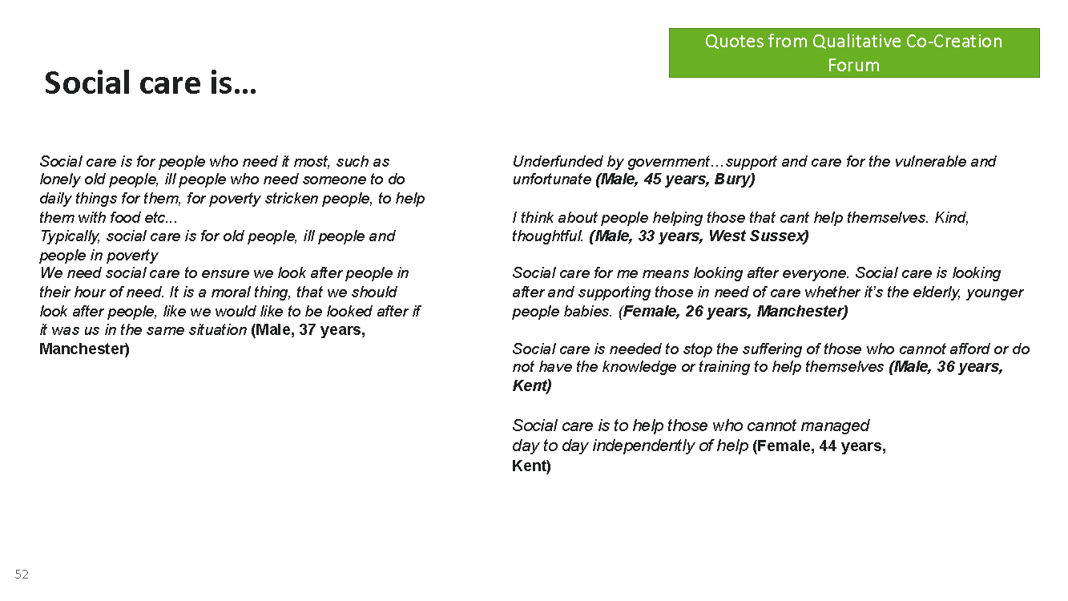

The media reinforces the narrative of a system in crisis

Media stories around social care tend to focus on the negative angles of challenges, funding, cuts and the stress that social care is under. Similarly, stories around abuse and mismanagement and poor experiences of staff working in a social care setting are picked up on to create a context of vulnerable people in a crisis situation, as the selection of articles chosen by some of our research participants shows. There is a heavy emphasis on funding, a crisis situation and a broken system.

All this reinforces the negative associations of a system that poses a problem rather than a positive benefit to the wider society.

Figure 2: Media stories chosen by participants that represent social care

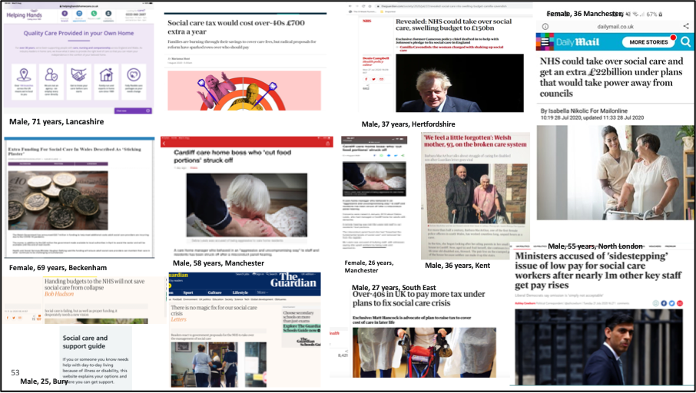

Many participants feel angry about the social care system in crisis and feel that it should be a greater priority. However, whilst this causes concern, the focus is on vulnerable people and neglect rather than building a care system with wider benefits for society.

“Adult social care in England needs fixing and has done for decades. Even before the pandemic, increasing numbers of vulnerable people were unable to access social care and care homes and providers were at risk of financial collapse. Covid-19 has ruthlessly highlighted the scale of policy neglect that the sector has experienced under successive governments, which have failed to come up with much needed reform…. It should be a natural duty to look after those in care and provide them with the care and security” (Co-creation forum participant)

“The media are only interested in social care when there’s a story to be told, usually something negative such as what people like to read. Very rarely do we see good news portrayed in the media. I’m not sure that politicians are really interested in social care. It may feature perhaps in their manifestos, but the reality is that it is way down the pecking order in terms of priorities and where public money is spent. I don’t feel as if there is any genuine impetus to drive the issue of social care to the fore”. Co-creation forum participant)

Quantitative Research
In our quantitative survey we asked people to select 3 words from a list that they most strongly associate with social care. Reflecting what we heard in our focus groups the top three words were more passive or functional descriptions such as compassion, vulnerability and safety. Very few people picked positive or active words such as choice, freedom and belonging as associations with social care.

Figure 3: Top 3 words associated with social care

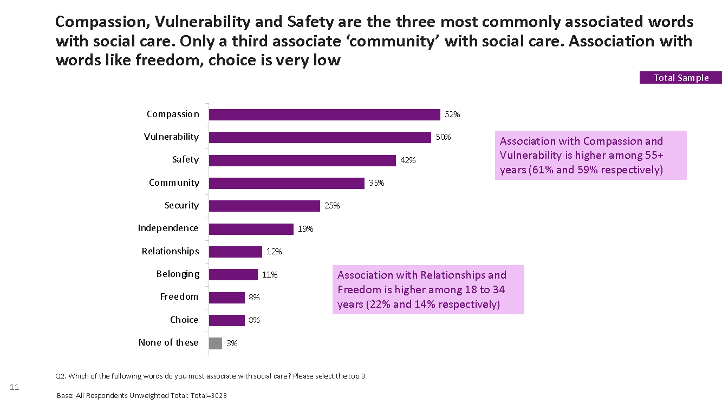

Similarly, we found that 60% of the public strongly agreed (8 or more out of 10) with the statement that social care ‘is about the places where we look after vulnerable people who can’t look after themselves’. Again, this mirrors what we heard in the qualitative research: when asked to pick out statements that best fit with their views on social care the top answer was ‘social care is about vulnerable people being looked after by regulated personal care services with support being delivered by care staff’

However, there are also reasons to be optimistic about shifting the narrative. 61% of people also agreed with the more positively framed statement that social care is ‘about having the support they need to live how, where and with whom they choose’ and 60% agreed that ‘I support greater government investment in social care’ and in our qualitative work we found that our participants tended to disagree with a statement that social care provides an insurmountable problem for society to fix ‘the demand from older and disabled people for social care is growing and providing an irresolvable pressure on societies resources’

Figure 4: agreement with statements associated with social care in the survey
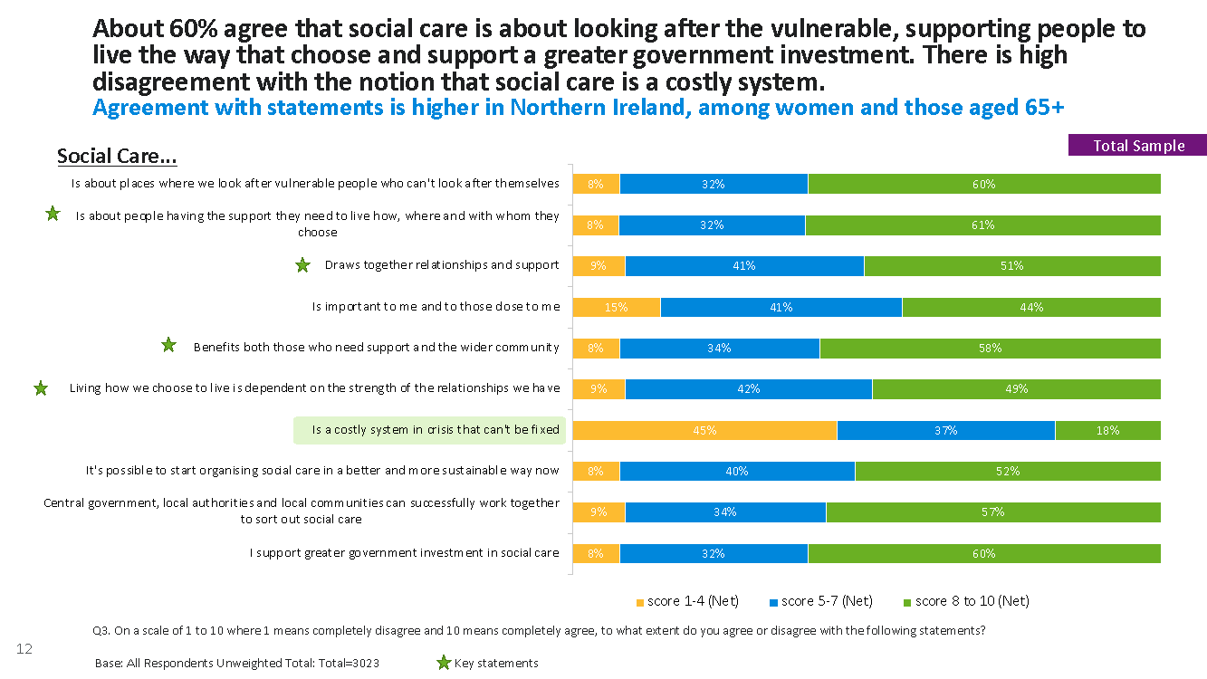

Hearts and minds – what values and beliefs underpin attitudes towards social care?

The public support government investment in social care and feel that change can happen

Whilst the dominant narrative around social care clearly does play into a frame of protecting and being compassionate towards the ‘most needy’ – there are positive indicators that if we delve deeper into the ‘hearts and minds’ of the public we find values and willingness to support a more positive framing of social care.

Firstly, social care is considered to be important, one of the top priorities after ensuring the NHS is adequately funded. The Covid-19 pandemic has highlighted the gaps in social care, particularly in terms of quality of provision for older people and created a focus on the sector where people are starting to see its importance as well as supporting reform. There is a long way to go in helping people to understand social care and moving away from a ‘crisis’ perception, but it is on the agenda for people right now in terms of what is considered important.

From our quantitative survey, when asked to pick from a list of what single issue should be the government’s top priority it is not a surprise that the NHS dominates with 52% selecting this as the top priority. However, when asked to pick ‘top 3’ issues, 78% of our sample selected ‘investing in social care’ when provided with a list of options, more than any other option apart from the NHS. This was even higher (83%) amongst the over 55s. Whilst participants were provided with a list to choose from – so may not reflect what is top of mind for people – this gives an indication that the pandemic has provided a context where people see social care as a priority for reform and investment.

Social Care should be improved also due to the numbers of people who are vulnerable and elderly who have been highlighted as suffering most throughout this pandemic. (online forum participant)

Figure 5: Priorities of the Government after the COVID-19 pandemic

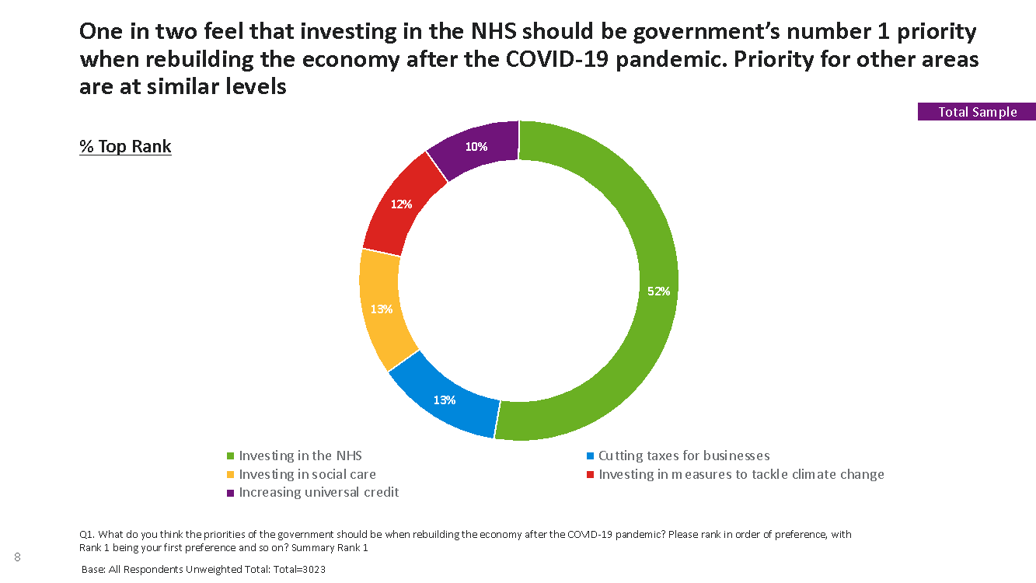

Figure 6: Top 3 Government priorities after COVID-19 crisis
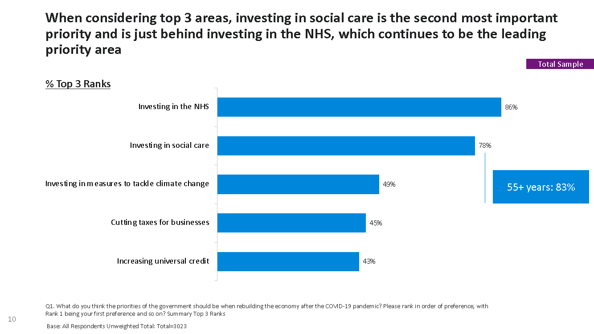

Vision of a ‘good society’ supports a new narrative around social care

Qualitative analysis

There are many different attitudes and beliefs about what makes a good society to live in, but amongst the ‘persuadable public’, dignity for all, equality, fairness and reciprocity were commonly mentioned as underpinning the kind of society we all want to live in. Whilst these values may not be immediately associated with social care today, they are very much in the hearts and minds of the general public and tapping into these values will help build public support for a new vision of social care

“I think a good society constitutes a friendly environment where people feel safe and can count on each other in times of need. I think it looks like what the UK was like during the war, where everyone just came together as one unit to help each other get through the tough times. Rules and values of a good society I believe are the society should be fair, equal, safe, friendly, where people treat people how they expect to be treated, same goes for the places they go and live, treat it with respect as it was their own....”(Online co-creation forum participant)

When we asked participants to take part in exercises to explore some of their deeper level associations of what social care means, more positive and active imagery around empowerment, support and lifting each other up emerged. These associated tapped into deep beliefs that people hold about treating each other with dignity and respect, being in control of our lives and offering mutual support to people in our communities. The most commonly picked images in this qualitative exercise shown below were (2) – showing a supportive lift and (11/12) showing people sitting side by side – a relationship, a supportive arm around the shoulder.

Figure 7: people and feelings images selected to describe social care

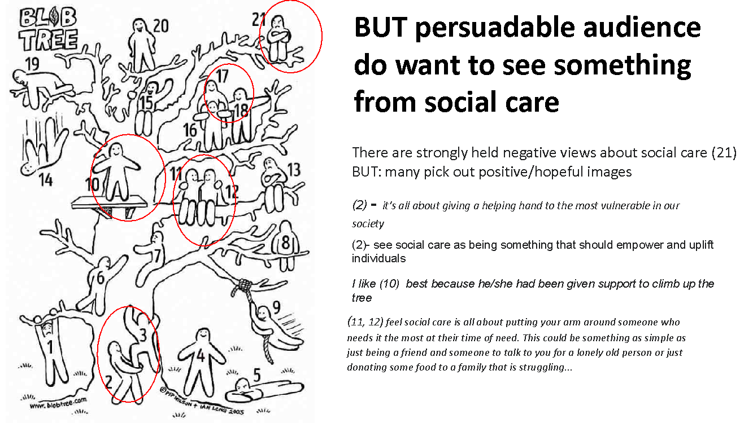

When people were asked to select images online to show how they feel about social care – of course, images around cost (money) and hand holding (care) were dominant themes. However– there were also important emerging ideas around equality of all (gender, race), dignity, respect, civil society, helping each other and happiness that many felt should play an integral part to social care.

Figure 8: Images chosen to represent social care

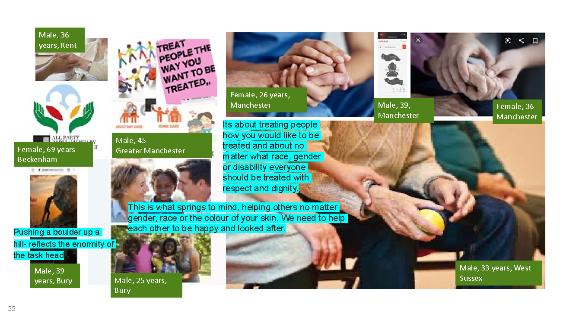

When we asked people what they would ‘name’ a new vision of social care many reflected on an emerging theme of togetherness and community to describe what they would like to see from an improved social care of the future:

- “People centred care”
- “Together we are stronger”
- “Community care: assistance to all those who need it”

Reframing social care

We can see that the dominant narrative of social care that #socialcarefuture identified in its previous research analysing media and advocate messaging is strong amongst the public. However, we also learnt from the research that there is potential to tap into more intrinsic values around self-direction, interdependence, community and equality to build a narrative aligned to #socialcarefuture’s vision.

SCF draft vision of social care already tapped into these values. When we began the research the vision was presented as follows:

Figure 9: vision statement presented in online co-creation forum

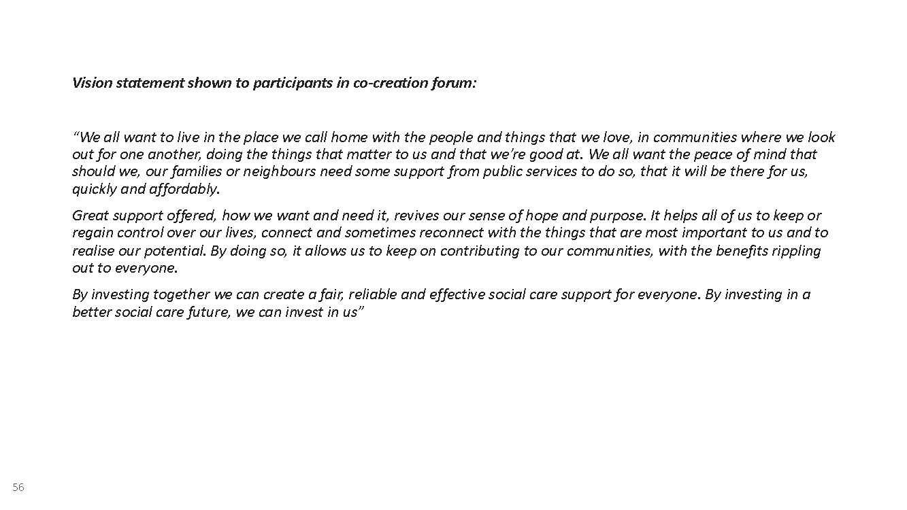

In our qualitative work we shared the SCF vision statement for review and we found that the overarching narrative of social care future shown in the first two lines of this statement “we all want to live in a place we call home” does tap into the underlying values of the persuadable public.

However, we also found that one of the main challenges faced in communicating this vision is ensuring that there is a clear, tangible and credible example of what good social care looks like and who or what is responsible for achieving it. Language such as “By investing in a better social care future we can invest in us” was ambiguous and caused confusion about who was responsible for paying for this vision of social care.

“It suggests if we walk, work together social care will be better and as a result everyone's lives will be better. It sounds like a cult. Promising everything, a utopia, with no cohesive plan to get there. I don't see this idea as realistic. I would support greater investment from the government but if it was to invest in this vague community based approach I would worry about the impact the investment would have.” (online co-creation forum participant)

“I liked the first part particularly about having good neighbours and communities. The rest, not so much. Too wordy for me personally and the part about everyone benefiting just doesn't seem true to me.” (online co-creation forum participant)

The challenge was therefore translating this vision for what social care is and does into a set of practical principles that people can fully support. Only when the public (and stakeholders) understands this vision in terms of the underlying aims and values AND the practicalities of how the vision will be realised can a shift in understanding be achieved.

Developing frames – what messages can we use to shift public perception and support

Taking on board the reactions to the SCF vision statement, a number of new narratives were created, using the principles of the SCF vision statement but also with a real-life example of how good social care can work and how the change could be made to ensure credibility.

The three narratives that we tested, each focused on one of these three sets of values:
- Security and belonging
- Community and interdependence
- Individual freedom and control

Security and belonging
A narrative that taps into the values of security and belonging is fundamental to what many perceive to be fundamental to the purpose of social care. For many people this reassurance “should be the norm” of what social care is about. This narrative also brings to mind that social care currently doesn’t always deliver on these fundamentals – that it too often falls short, being a broken system, badly funded, open to abuse and with staff who are stretched to their limits.

There are positive reactions to the idea of security and belonging, using technology and services that are centred around the home to give people choice and to allow people to be in their own surroundings safely.

“Because a sense of security and safety and belonging is very important and tangible.” (Red Wall, 50+)

What we learned about invoking security and belonging:
- Invoking security and belonging can be helpful in reassuring people that any new vision of social care is designed to meet people’s basic needs
- BUT: take care not to rely on invoking security too heavily - on its own may reinforce existing paternalistic frames of social care (about the vulnerable and needy) and does not do enough to create a new narrative or shift people to think about the issue differently
- Do use the value of security to show the potential for care within a familiar home environment – having the tools to live life safely at home is powerful

Figure 10: Security and Belonging narrative shown in focus groups

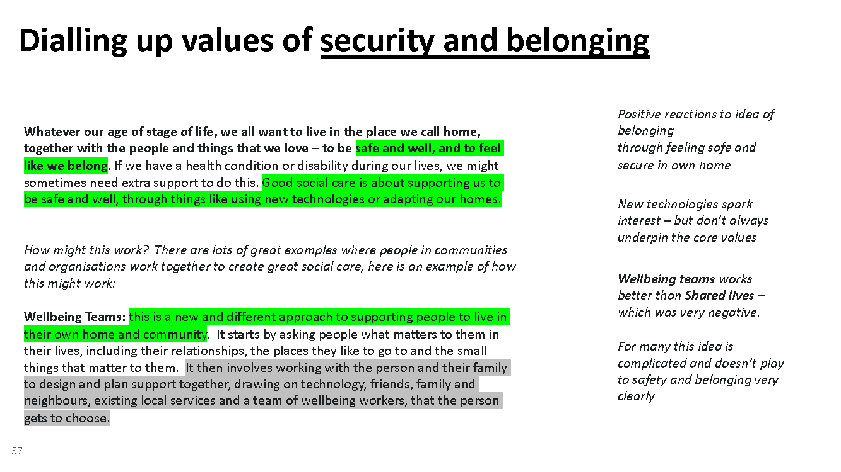

Community and Interdependence
Invoking the values of community and interdependence is a positive and aspirational vision, not often associated with the negative stories and dominant narrative around social care in an institutional setting.

Communities coming together has been a theme of the Covid-19 pandemic – which taps into the current mood and also resonates with older people who feel a sense of nostalgia about a more connected society. We don’t know how long this sense of community and togetherness will remain top of mind for people once the pandemic is brought under control, which suggests the need to leverage the opportunity to communicate around this current sense of community and connection as soon as possible

Framing the story of social care around community and interdependence creates a sense of hope, optimism and confidence and a sense of connection and reciprocity “happy about more connected lives”

“I think it is showing if we ALL work together...really great things can be done” (London/SE, 30-49 years)

One watch-out for the community narrative is to ensure that people see national and local government as taking responsibility and not passing the buck to unpaid volunteers.

What we learned about invoking community and interdependence:
- These values tap into the pandemic ‘spirit’ and strongly resonate – it seems to be the right time to talk about the role of communities
- Ideas of being connected and maintaining a sense of purpose appeal to people, and help to suggest that social care has a wider relevance and benefit than just for the individual who receives it
- Take care not to play into concerns about overstretched voluntary and unpaid sources – demonstrate how it will work and make clear the role of national and local government.

Figure 11: Community and Interdependence narrative shown in focus groups

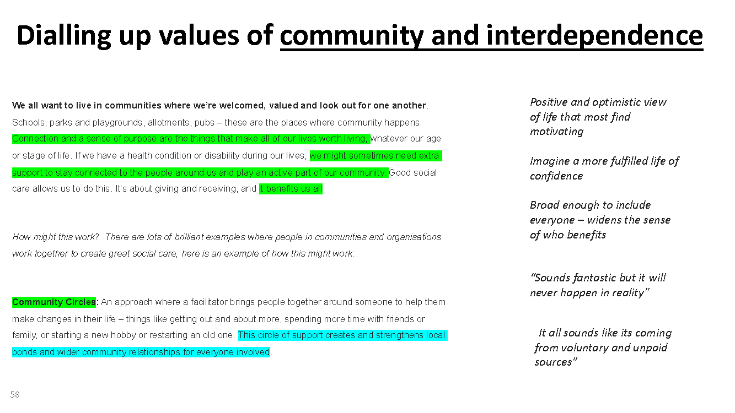

Freedom and control
Using a frame underpinned by the values of self-direction proved the most difficult for people to grasp and stretched people furthest from the current dominant narrative. When people think about social care they think of the ‘deserving needy’ and hence there is a level of dissonance in thinking about freedom and choice (combined = self-direction) as many question whether people they regard as ‘needy’ can make the right choices in life.

“Ah, this is a tough one. used correctly, it would be fantastic to give individuals control over their budget. but also it could be abused. addicts and people with mental illnesses might misuse this funding. people lacking the capacity to know how to use money well might blow their funding on things that aren't really going to improve their lives.” (London/SE – 30-49 years)

However, it is important to note that the reaction of participants in the focus group to this value appeared to be influenced by the practical example provided, which was ‘personal budgets.’ This led to a great deal of focus on whether people could be trusted to spend public money, more than revealing fundamental disagreement with the principle of people being in control of their own support and their own lives.

What we learned about invoking values of freedom and control
- Invoking values of freedom and control through talking about people being cared about not cared for and by talking about staying in control of our lives is very powerful and encourages people to see recipients of social care in a less passive way and for it to be recognised as having more immediate personal relevance.
- However, talking about budgets and individuals controlling their own spending triggers unhelpful associations: “A vulnerable person might go without due to poor budgeting”

Figure 12: Freedom and Control Narrative Shown in Focus Groups

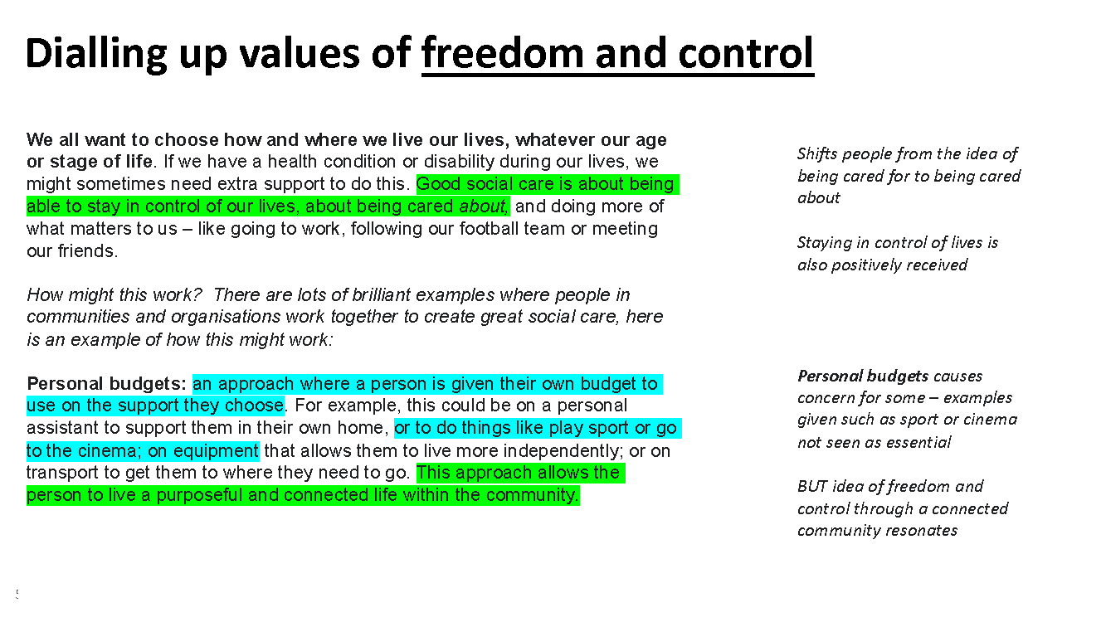

Overall, from exploring different values from security and belonging, to community and interdependence and freedom and control, we found that there is a place to invoke all of these values when talking about social care. However, how they are used, and which values are most helpful in eliciting public support for SCF’s vision vary.

Invoking security and belonging values is important as it speaks to what many regard as the foundations of good social care. However, relying on these values alone does not shift people’s thinking in the direction of SCF’s overall vision, with its emphasis on community, freedom and control.

Invoking freedom and choice on its own is a big leap for the public and using strong messaging around these values can be a stretch too far from the dominant frames that people understand, switching them off. However, they can be introduced through messaging such as ‘being cared about not cared for’ or ‘staying in control of our lives’ which help to communicate that good social care is not about ‘doing things’ to people without them having a choice or a voice.

Finally, invoking community and interdependence is a good way to bridge the gap between the dominant narrative and the vision of social care that #socialcarefuture wants to see. Talking about relationships and connections taps into a sense of community, that has emerged strongly through the pandemic and people’s experiences of the last 12 months. Talking about social care in the context of human stories, people and communities broadens the sense of ‘us’ and taps into shared values of fairness and equality.

How can we use metaphors to communicate our message?

As we have seen, there is a lot of public confusion around social care, and it can be complex to communicate about good social care clearly. This is where using metaphors can help.

Using metaphors to aid understanding

Metaphors are highly visual and can help convey complex information clearly and quickly.

As part of this research we tested a number of metaphors which were designed to create mental ‘shortcuts’ to one of three sets of values around security and belonging, community and interdependence and freedom and control. Security and belonging speak to what many consider the foundations of good social care but used alone they don’t shift people’s thinking in line with SCF’s vision of social care, centred as it is on individual freedom and control and the role of relationships and community in enabling this. Similarly, while using individual freedom and control alone can help shift the focus from cared for, this neglects our interdependence and doesn’t broaden the sense of ‘us’. There is a place to invoke each of these values when talking about social care. But how they are used and in what combination is important, as they perform different roles

SCF and Equally Ours led a session at SCF’s February 2020 gathering in Manchester to generate metaphors that could be used to describe what good social care is like - a wide range of suggestions were made:

Figure 13: metaphors generated at the SCF’s gathering in Manchester 2020

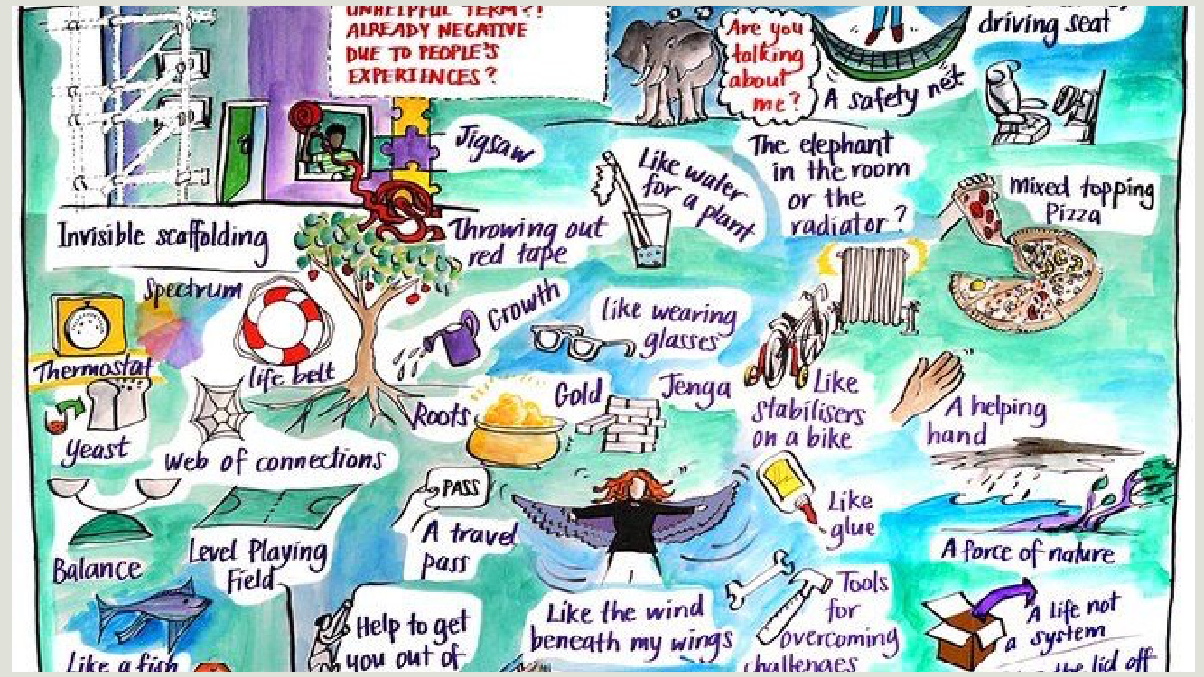

We tested a number of these different metaphors in our qualitative focus groups to understand which ones stuck in people’s minds and which were most helpful in building support for #socialcarefuture’s vision.

Qualitative Testing of metaphors

Figure 14: Metaphors invoking security and belonging tested in focus groups

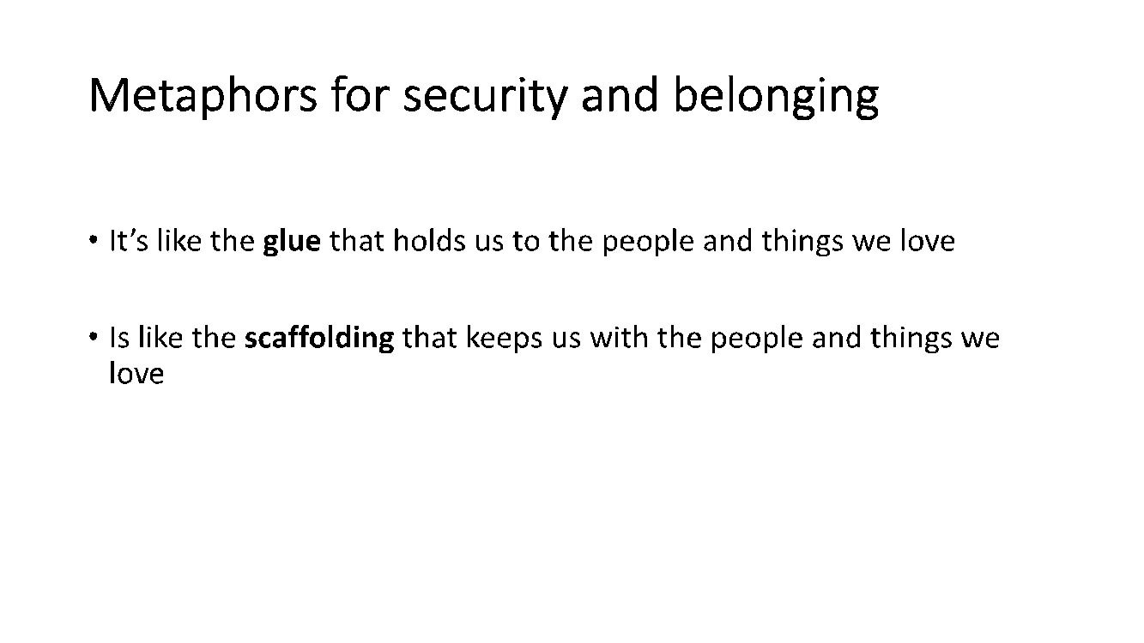

Scaffolding proved to be an interesting metaphor as it is strong and emotive, but participants drew both positive and negative associations. For some it clearly evoked a support structure and works well to convey a sense of safety around a person. However, for some, using ‘scaffolding’ as a metaphor also suggests fixing a problem, and as a temporary structure that can be seen as emotionally cold and industrial. Overall, Scaffolding didn’t work well enough to convey the idea of social care that #socialcarefuture wishes to communicate.

Glue is a better metaphor to use to convey a sense of belonging and connection – it helps people to quickly think about “coming together and sticking together, the glue that bonds”

Figure 15: Metaphors invoking community and interdependence tested in focus groups
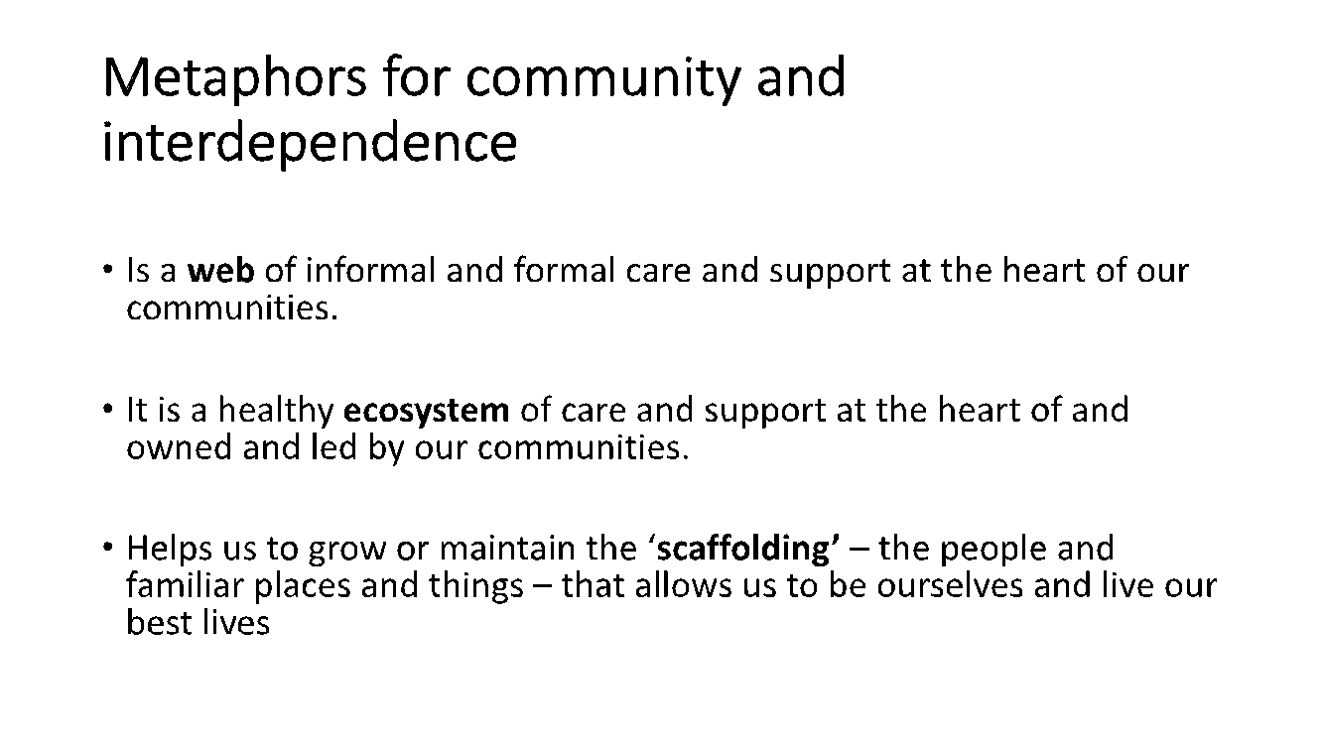

Again, scaffolding did not work well among participants as a metaphor to convey community and interdependence – it did suggest a support structure, but it did not convey a human connection based on relationships. People did however express keenness on the emphasis on ‘meaning, purpose and connection’ that was used in the ‘scaffolding’ message.

Web of care was the strongest of the metaphors we tested in the qualitative focus groups for conveying connection and interdependence. A healthy ecosystem also worked as a metaphor to convey connectivity – but not everyone understands the term, so whilst it worked for those who did understand it, it may be quite limited.

Figure 16: Metaphors invoking freedom and control tested in focus groups

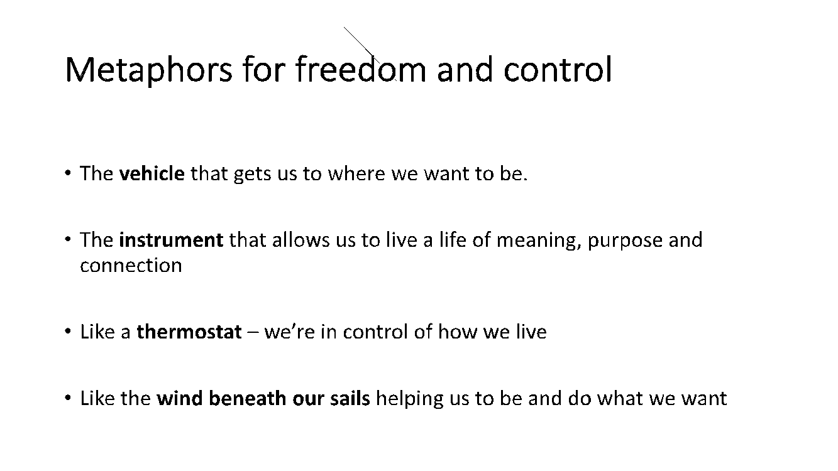

The most successful of these metaphors in the qualitative focus groups was ‘vehicle’ – as vehicle clearly evokes a sense of direction and movement forwards. Other metaphors suggested for this value included ‘tools’ to help people to do the things they want to do. However, the freedom and control metaphors didn’t resonate as strongly with people as those that conveyed community and connection.

Overall, Metaphors that evoked a sense of community and connection were the most positively received as these aligned most closely to the narrative that people most associate with their own conception of good social care.

Quantitative testing:

Once the metaphors had been explored in qualitative research, we tested a number of them further in quantitative research. In the focus groups we found that the sentence that was used to provide context to the metaphor sometimes had a strong influence on how the participants understood and evaluated the metaphor. In the quantitative test we ensured that contextual sentences were kept as similar as possible, with the metaphor as the variable.

The sample was divided into 5 groups, each group saw one of the metaphors shown below. Participants were asked a number of questions about social care before they saw the metaphor and then again after they had seen the metaphor.

Figure 17: Metaphors tested in the quantitative survey
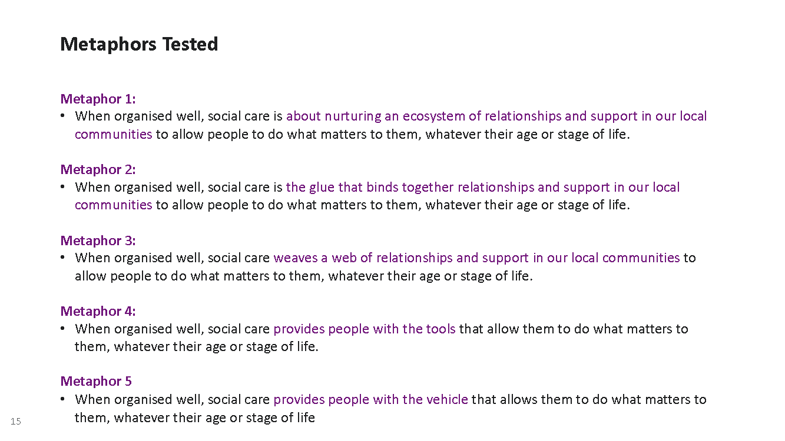

We found that overall, post reading the metaphor statements perceptions had shifted positively, particularly around measures relating to community and support.

When we look at the total sample (those who had seen any of the 5 metaphors) we saw a statistically significant increase in people strongly agreeing with the following statements after they had seen one of the metaphors.

- Social care is about people having the support they need to live how, where and with whom they choose
- Social care draws together relationships and support
- Social care is important to me and those close to me
- Living how we chose is dependent on the relationships we have
- It is possible to start organising social care in a better and more sustainable way now

Figure 18: agreement with statements about social care before seeing metaphor statements vs. after seeing metaphor statement
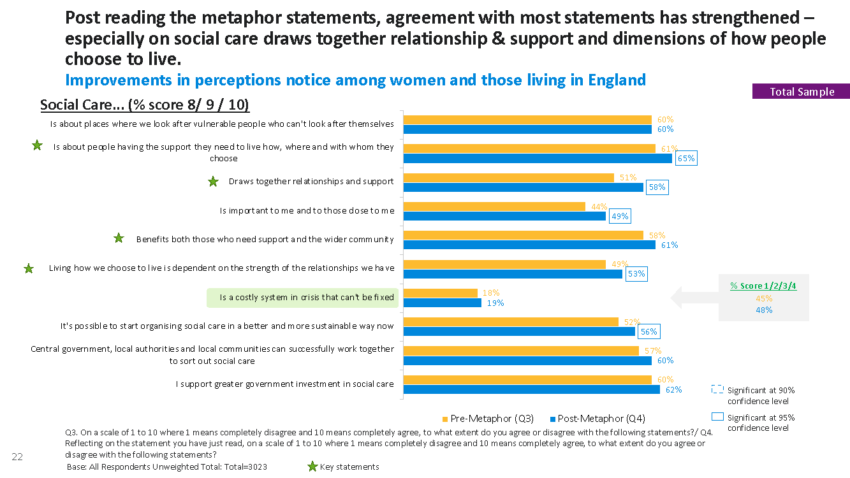

We can also see that some metaphors worked better than others in shifting perceptions in line with #socialcarefuture’s vision. Metaphors that related to community and interdependence (metaphors 1,2,3) were more likely to have move perceptions of social care towards #socialcarefuture’s vision than metaphors that related to freedom and control (metaphors 4,5).

Exposure to ‘Nurturing ecosystems’, ‘glue that binds’ and ‘web of relationships’ all resulted in statistically significant increases in scores with the statement ‘draws together relationships and support’. ‘Web of relationships’ also led to a significant increase in those agreeing that social care is ‘important to me and those close to me’ when people had seen this metaphor.

There were no significant shifts amongst those who saw the metaphors about self-direction ‘tools’ and ‘vehicle’ when these metaphors were seen in isolation.

This suggests that using metaphors, particularly ‘Nurturing ecosystems’, ‘glue that binds’ or ‘web of relationships’, can help to shift perceptions of good social care towards #socialcarefuture’s vision and approach.

Self-direction metaphors (tools and vehicle), on their own, were not as strong in communicating the #socialcarefuture, but they can be valuable when used in combination with other parts of the vision statement.

Figure 19: summary of which metaphor statements were most effective in shifting perceptions on key measures
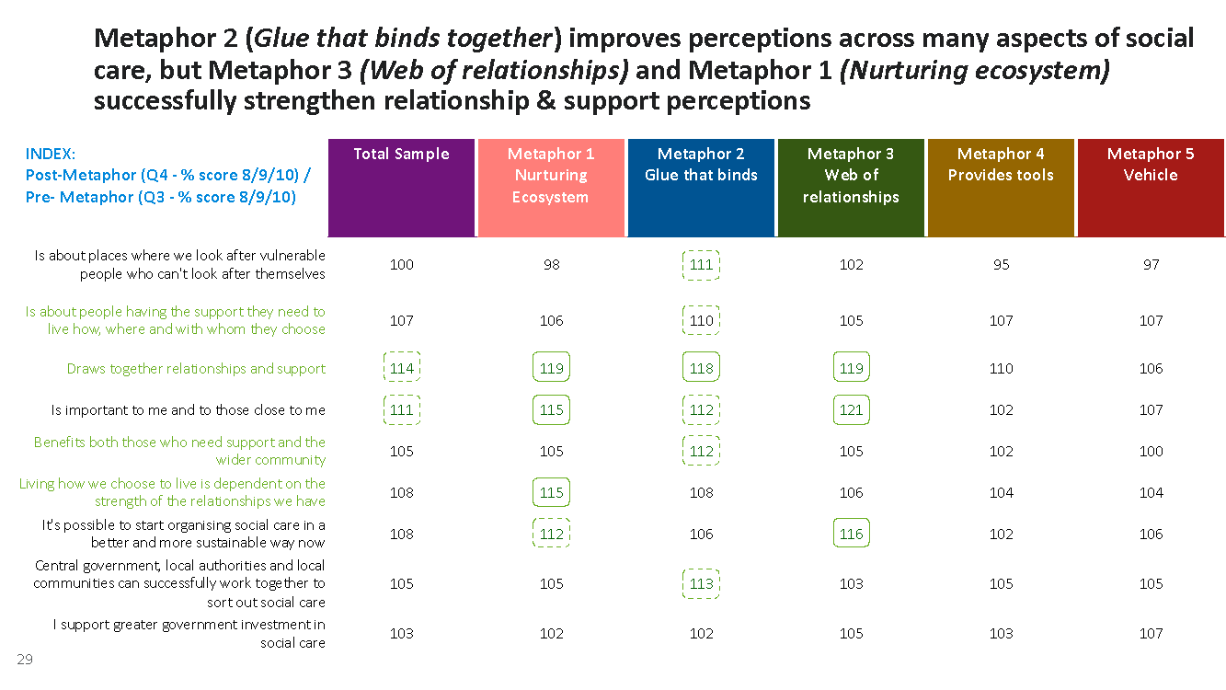

Communicating the SCF vision statement shifts attitudes towards social care
After participants had seen the metaphor statements, they were also asked to read a #socialcarefuture vision statement that was built on the original #socialcarefuture vision but also incorporated all the learnings from the two waves of qualitative research to optimise the effectiveness of this statement.

Two versions of the vision statement were shown, each with a different end paragraph but with the majority of text being the same. The metaphor that people had seen in the earlier part of the survey was included in the vision statement so it could be evaluated in the context of more detailed information, not just evaluated on its own.

The vision statement took the learnings on board as follows:

Opening paragraph – tapping into pro-social values that we all share
“We all want to live in a place we call home, be with the people and things we love and do the things that matter to us, in communities where we care about and support each other” – from the qualitative stages we found that this opening statement tapped into important social values and played to the idea of lives having meaning, purpose and connection.

Second paragraph: reinforce the ‘us’ and explain the role of social care
The second line in the value statement “If we, or those close to us, have a health condition or disability during our lives, we might need some extra support to do this. This is the role of social care”. This sentence explains how anyone of us may need social care at some point in our lives, it gives a sense of social care offering support and not being restricted to ‘other’ groups of the most ‘needy.’

Third paragraph: metaphor to provide a way to reinforce the points
Participants were shown the one metaphor – the one that they had evaluated earlier in the survey – to reinforce the message they had already been exposed to rather than bring in a new variable and to explain the role of social care.

Fourth paragraph: provide a clear and practical example of what good social care can look like. Learning from the qualitative phase the fourth paragraph of the vision statement showed an example of how social care can be organised differently and an example of how this would work. We avoided using the more contentious example of personal budgets.

Final paragraph: shows who is responsible for this change. The two vision statements differed in their final paragraphs which showed two messages about the agent of change:

V1: The government must make good social care a priority and begin investing more in it. And more local councils need to think differently about how they can organise and fund social care, learning from investing in these new and more effective ways of doing things now.

V2: The government must make good social care a priority and begin investing more in it. And more local councils urgently start working alongside and supporting local people and organisations to bring these ideas to life by organising and funding social care differently.

Figure 20: vision statement 1 & 2 shown in the survey
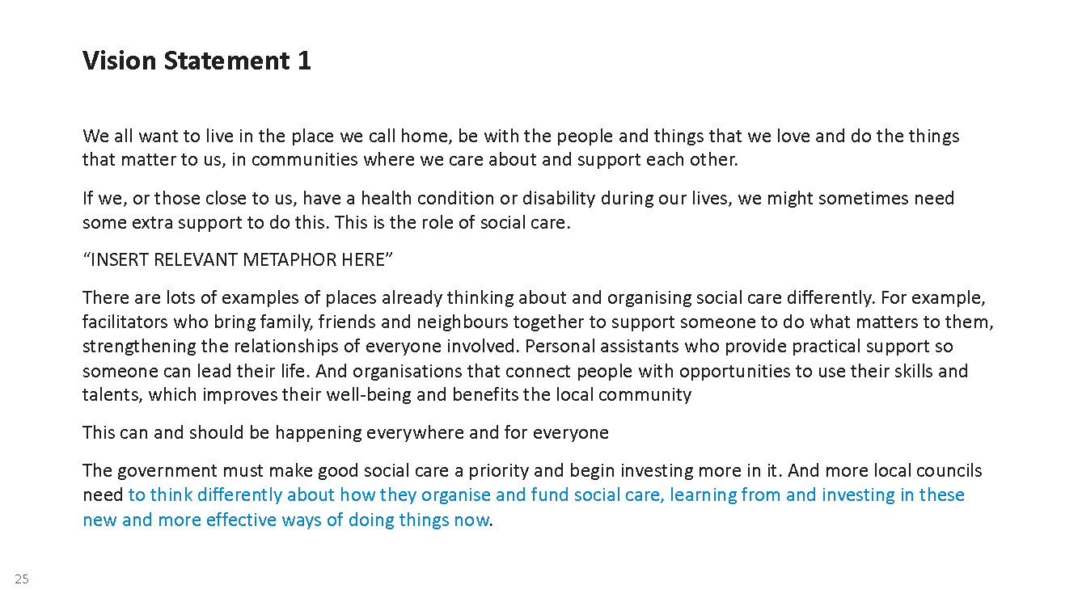
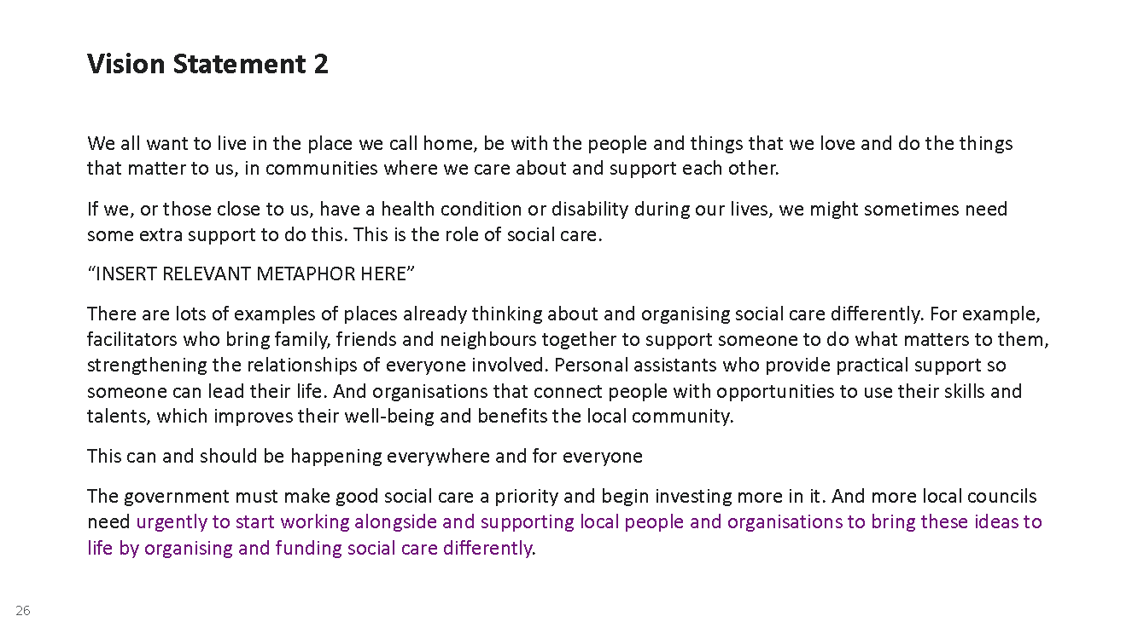

Overall, the result of seeing either V1 or V2 of the statement showed a clear and statistically significant shift in alignment to #socialcarefuture’s vision, as tested across key measures, highlighted in the chart on the following page.

Participants were more likely on a statistically significant basis to agree that social care is ‘about people having the support they need to live how, where and with whom they choose’ (increasing from 61% agreeing at the beginning of the survey to 70% after seeing the statement). ‘Draws together relationships and support’ increase from 51% agreeing to 65% agreement. ‘Benefits those who need support and the wider community’ increased from 58% agreeing to 68% agreeing afterwards. Lastly, ‘living how we choose to live is dependent on the strength of the relationships we have’ increased from 49% in agreement at the start of the survey to 60% after the statement had been seen.

This showed in the quantitative research that the vision statements both had a positive impact on aligning people to the #socialcarefuture’s vision and that when seen in the broader context, we saw that none of the metaphors had a negative impact.

Figure 22: Key statements before and after seeing vision statement and metaphor in survey
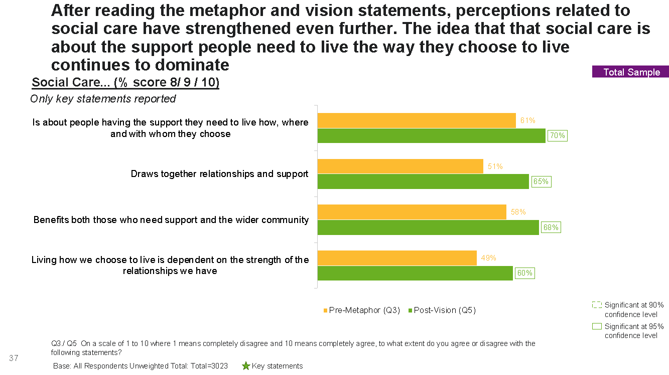

Looking at other metrics, after seeing the vision statements we saw a statistically significant increase in participants selecting more positive, active and relationship focused words to describe social care than they did before they saw the vision statement and metaphor. We saw a shift away from passive and paternalistic words such as compassion and vulnerability being selected.

Community, independence, relationships, belonging, freedom and choice all increased as a top three words association with social care after the vision statement and metaphors were seen. As a consequence there was a decrease in the selection of passive and paternalistic words. Compassion fell from 52% to 36%, vulnerability from 50% to 27% and safety from 42% to 28%. This suggests that it is possible to influence and nudge the public to see social care differently using the communication tools that both tap into values and follow through with a clear and practical example of how social care could work in practice and how it could be funded differently.

It is worth noting that there was no significant difference between those who had seen vision statement 1 vs. vision statement 2. Also, the increase in positive active words being selected applied regardless of which metaphor had been seen.

Figure 23: Top 3 words selected before vs. after seeing vision statement and metaphor

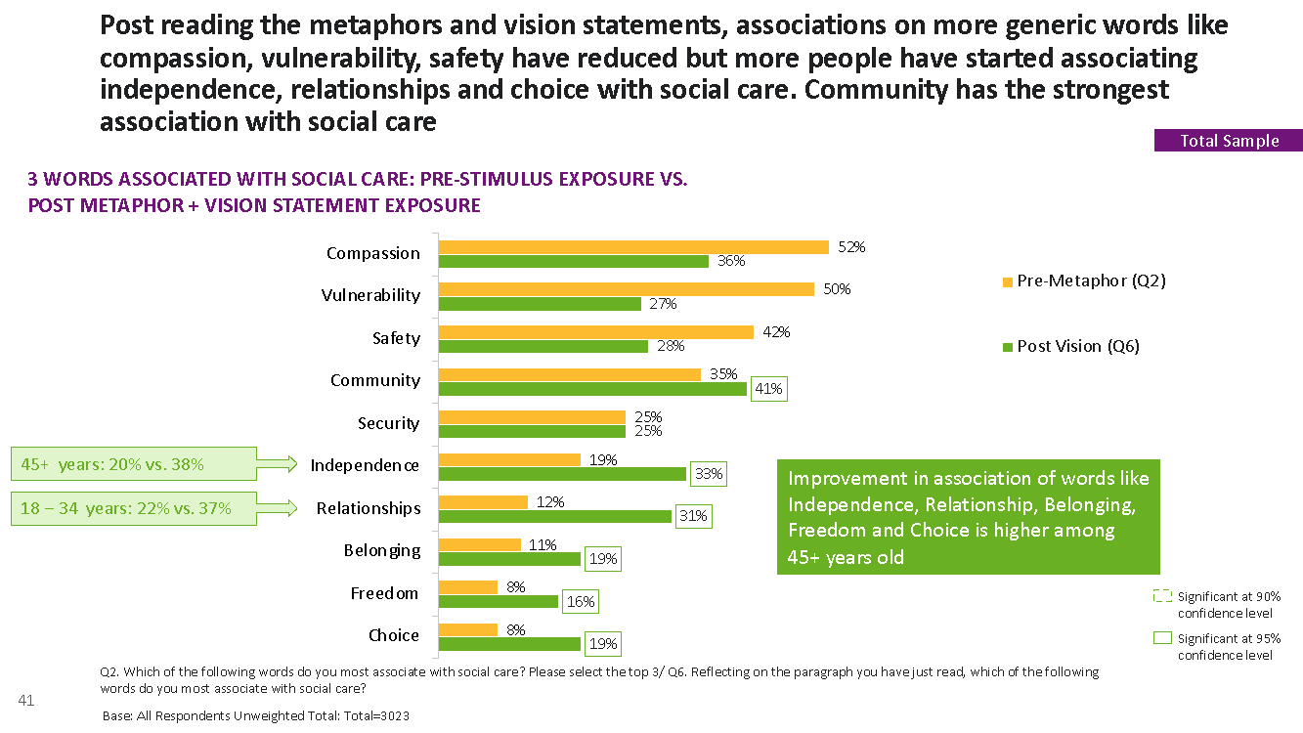

When evaluated out of context we saw that the metaphors for ‘vehicle’ and ‘tools’ were less effective than the other metaphors in helping to deliver #socialcarefuture vision for social care. However, we can see in the chart below that exposure to the metaphor ‘vehicle’ within the context of the vision statement still results in a statistically significant positive shift towards words including choice, freedom, belonging and relationships being selected in association with social care – although not such as shift in selection of community.

This demonstrates that on their own metaphors relating to freedom and control such as vehicle are not as evocative and powerful, they can be used within the context of broader communication with no detrimental impact.

What we can conclude from the quantitative experiment of showing the metaphors and vision statements in different combinations is that when seen in a broader context none of the metaphors was particularly stronger than another. It appears that the impact of the vision statement with all its components served to shift perceptions, and it suggests that the elements that remained consistent – appealing to values, emphasising the role of community, expanding the ‘us’ and giving a clear practical example of how social care could work were clearly influential in shaping perceptions.

The other factor is that the vision statements had different statements about how change will be delivered. V1 is about local councils doing and investing differently. V2 is about councils working with and supporting local people and organisations. Both of them emphasised that the government should make good social care a priority. Whilst we can’t conclude from this research that either of these ways of talking about change works better than the other, it is likely that having a clear description of how funding needs to be organised and what ‘investment’ means has a role to play. We saw in the earlier qualitative work that talking about investment and funding could put people off. In the right context, where the agent of change is clearly described it can be seen more broadly than simply about money and to be less off putting to people.

Figure 24: Associations with key words after being exposed to ‘vehicle metaphor’

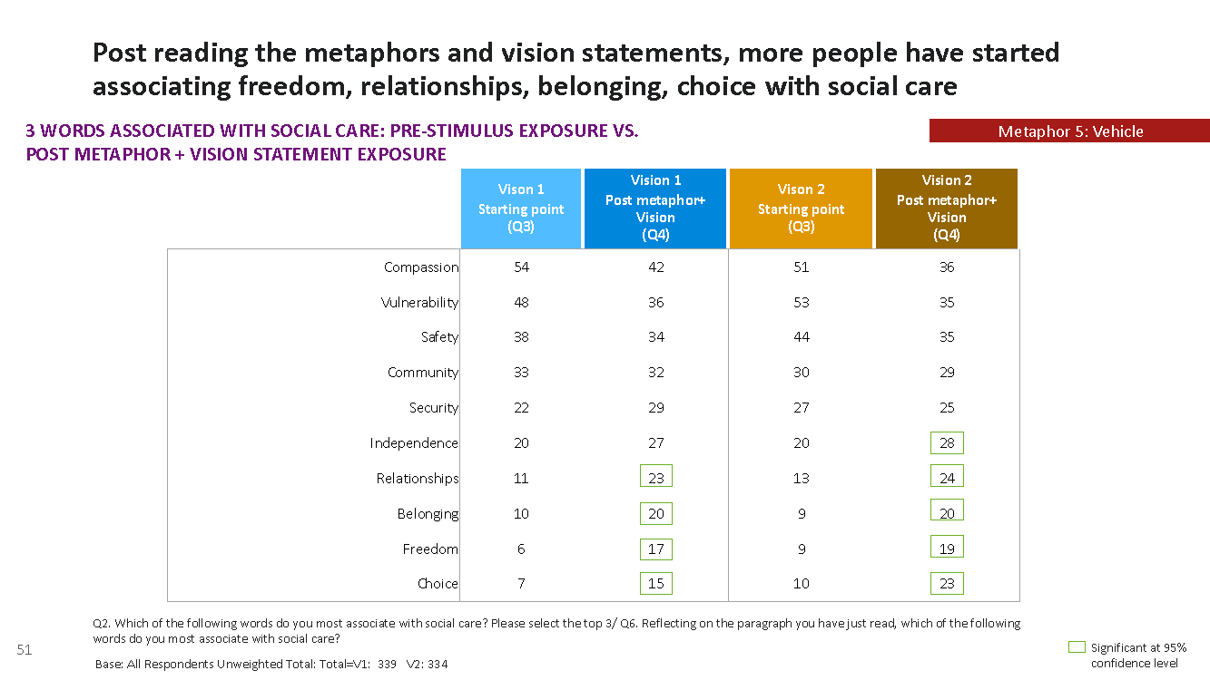

Overall, when participants had seen the vision statement (including the statement about how funding and investment could happen) participants were also more likely to prioritise the government investing in social care than they were before they had been exposed to this information.

84% selected social care as a top 3 priority after they had seen the vision statement, increasing from 78% before this information had been seen.

There was no significant difference in likelihood to support prioritising investment in social depending on which vision statement was seen; all worked to improve support for investing in support for social care as a priority.

Figure 25: Top 3 priorities for government investment after seeing vision statement and metaphor in survey
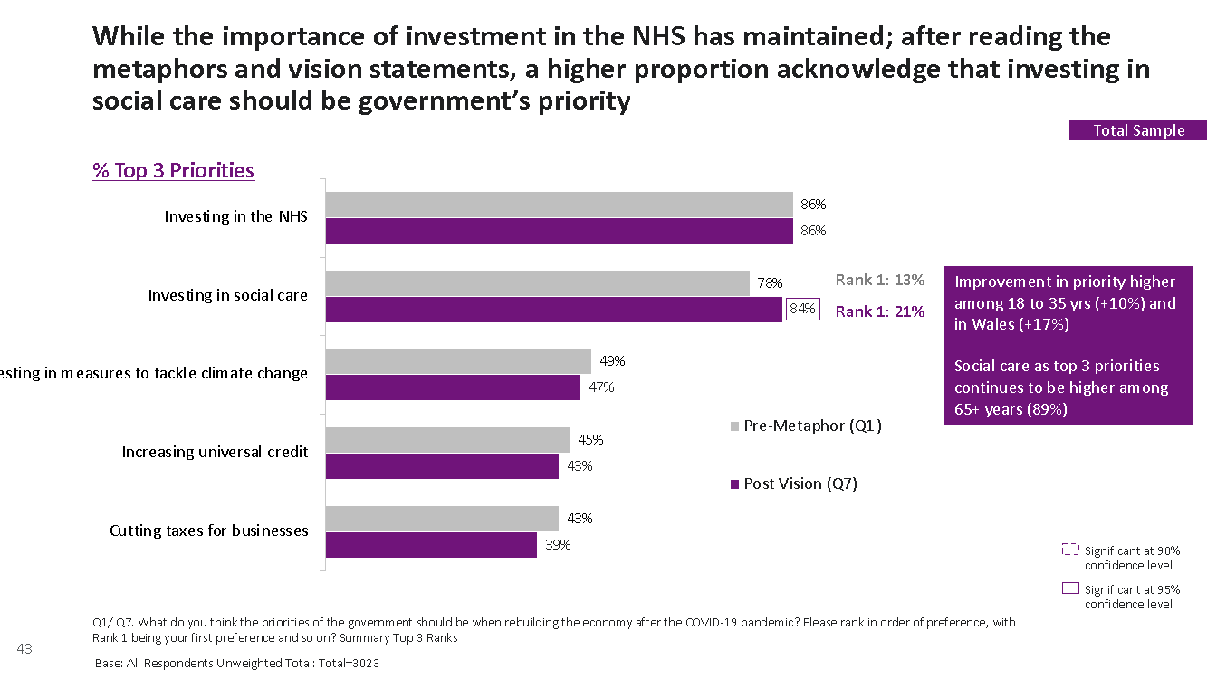

The new story – using the lessons of this research

This research shows that how the public thinks, feels and talks about social care reflects the dominant framing of it as a stretched and poorly organized system for ‘vulnerable’, passive recipients, needing to be looked after and unable to make a genuine contribution to the society around them. Whilst this view may be intended to elicit sympathy and compassion and create urgency for reform, the danger is that people feel distanced from it. This way of talking about social care causes people to ‘other’ those who require or draw on social care and leaves them feeling despondent about the potential for change. In this context, social care is seen as for other people, and the benefits that good social care can bring for their communities and their family lives is not recognised. This means that support for a new and sustainable way of organizing social care is hard to achieve.

The spotlight on care homes and the ‘vulnerable elderly’ during the pandemic has however created a focus that suggests that social care does need investment and the majority of people agree it should be a top government priority. The pandemic has also highlighted the importance of community, relationships and connections to people in their everyday lives. The public has experienced the importance of communities around them as well as the pain of being separated from the connections of family, friends and colleagues. This research shows that there is potential to act now and tap into this narrative of relationships and community to encourage a shift in how good social care should be a part of the communities we want to live in – people being being cared about, being treated with dignity, in a place called home.

We can see clearly from the results of our survey that through articulating a vision of social care which taps into the combination of values – safety and belonging, self-direction and interdependence, we can build understanding of and support for #socialcarefuture’s vision and in turn for support increased investment and focused action by national and local government.

There are also challenges with communicating the #socialcarefuture vision. It is more difficult to communicate the values of freedom and control and metaphors that suggest self-direction such as a “vehicle” or “tools” are less likely to help communicate the new vision when shown in isolation. However, vision statements including all 5 metaphors encourage a move away from more traditional, passive word associations with social care, with more empowering and active words being selected.

Importantly, throughout this research we have taken an iterative approach, refining and adapting how we communicate the SCF vision most effectively. The quantitative research demonstrated that by taking on board these learnings in the way the vision is communicated people are willing to see social care in a different light.

The vision statement clearly stated to people values underpin good social care – meaning, purpose and connection to communities. It also demonstrates how social care can impact on anyone, not just the most ‘vulnerable’ and ‘needy’. Avoiding an over-emphasis on self-direction on its own (particularly if using financial terms) was also an important learning. However, self-direction is an important cornerstone in the #socialcarefuture vision, so should be used in combination with other values.

We also found through the qualitative research that a values-based message without clear and tangible examples of what social care looks like and by whom it should be organised and funded could switch people off and lead them to dismiss the goals as unrealistic and unachievable. The vision statements tested in the quantitative research clearly provided a tangible example about who is responsible for delivering change – central government, local government and local organisations. Whilst there was no clear ‘winner’ in-terms of which agent of change message worked best – we can see from this research stating how change will happen does reinforce overall support for the vision (lacking when we tested the original vision statement in the qualitative sessions).

Finally we can see from this research that prioritising government investment in social care is strong and increases even further when seen in the context of the #socialcarefuture vision.

Appendix

Appendix 1 Focus group discussion guide

Focus group timings/structure
Group 1: Tuesday 20th October 6pm-8pm  North/Red Wall  30-49 years old  Mix of men/women  Include BAME representation  Middle income  ‘Centre’ politically – including 2019 Conservative voters | Group 3: Monday 26th October 6pm-8pm  North/Red Wall  50-75 years old  Mix of men/women  Include BAME representation  Middle income  ‘Centre’ politically – including 2019 Conservative voters
Group 2: Wednesday 21st October 6pm-8pm  South/London  50-75 years old  Mix of men/women  Include BAME representation  Middle income  ‘Centre’ politically – including 2019 Conservative voters | Group 4: Tuesday 27th October 6pm-8pm  South/London  30-49 years old  Mix of men/women  Include BAME representation  Middle income  ‘Centre’ politically – including 2019 Conservative voters

- Introduction (2-3 mins)
Whiteboard 1: welcome

The purpose of this section is to do a brief introduction and set out the parameters of the discussion this evening
Thank you for attending the online discussion this evening. My name is Jane/Darren and I work for the research and opinion company Survation. We are here to have an informal discussion today about issues to do with our community and society. There are no right or wrong answers, we are interested in what you have got to say! Please be as open and honest as you can, we have a number of different ideas to discuss with you.

As this is an online text discussion, you will need to type your answers to each question in the box and then we will discuss everyone’s views. Try and answer as many questions as you can, and don’t worry about waiting to see what other people are saying. I will also be showing you some information on the screen to read through and comment on throughout the session.

- Warm up (5-10mins)

The purpose of this section is to find out a bit more about the respondents and their current mindset before we move into the next sections

To start with, I’d like you all to introduce yourselves. Please can you tell me a little about yourself, your name, age and whereabouts you live and whether that is in a city/town/village.

Can you tell me what you do on a day to day basis? E.g. are you working, studying, caring for someone, retired?

What’s life like for you at the moment? How have you been getting on during the pandemic? Has the pandemic influenced how you feel about our community and society at all? Why /why not?

The government has been talking over the last few weeks about ‘building back better’ after the pandemic? What would you like to see the government focusing on? (Look out to see if things like health, social care are mentioned).

- Social Care Introduction (15-20 mins)

The purpose of this section is to touch on social care to start the discussion and build on what we heard in the online forum sessions

So, I want to start off by finding out what your views are on a few topics now. Firstly I’d like you to think about “social care”

Whiteboard 2: Social Care (plain text no images)

What words/thoughts/feelings come to mind when you think of social care? Do you feel positive or negative?

How would you describe social care and what it is for?

How do you think social care is seen and valued in this country?

Why do we need social care?

Who benefits from social care? If you were to describe a ‘recipient’ what comes to mind?

Is social care relevant to you? Have you or anyone close to you benefitted from social care? Is good social care beneficial to everyone? Why/why not?

Do you think there are problems with social care? What sort of problems?

What would good social care look like? Who would benefit from good social care?

Whiteboard 3: Word Association for social care
Pick 2-3 words that best describe how you feel about social care and explain why?

- Social Care Vision – Exploring the SCF Vision (1 hour – 1 hour 15 mins)

In this section we will explore different articulations of the vision statement - Each will include values dialled up/down, alternative explanatory metaphors, approaches to include wider benefits
Now we are going to look at some different ways of thinking about social care and we are interested in what you think of these – your first thoughts and impressions.

SCF vision 1 [ invoking community/interdependence values]

Here we will show the Community/Interdependence values vision statement, where these values have been dialled up. We will discuss what this means to people. We will show the visions statement and the ‘community circles’ solution as one idea of what this might look like.
Once this vision and solution has been discussed we will discuss the metaphors

Whiteboard 5
We all want to live in communities where we’re welcomed, valued and look out for one another. Schools, parks and playgrounds, allotments, pubs – these are the places where community happens. Connection and a sense of purpose are the things that make all of our lives worth living, whatever our age or stage of life. If we have a health condition or disability during our lives, we might sometimes need extra support to stay connected to the people around us and play an active part of our community. Good social care allows us to do this. It’s about giving and receiving, and it benefits us all
How might this work? There are lots of great examples where people in communities and organisations work together to create great social care, here is an example of how this might work:

Community Circles: An approach where a facilitator brings people together around someone to help them make changes in their life – things like getting out and about more, spending more time with friends or family, or starting a new hobby or restarting an old one. This circle of support creates and strengthens local bonds and wider community relationships for everyone involved.

Read through the whiteboard and use your highlighter to select any words/phrases/ideas that stood out to you
What are your first impressions of this idea? What is its main message?
How do you feel reading through this? What emotions do you feel – explore whether people feel positive, hopeful, engaged
What was being said here about the values of social care? What value does it have – for individuals, families and communities?
Probe: what sense of community, independence did you get here from this idea?
Show word association- which words do they pick out to describe the idea of social care that is being presented here
Does it seem credible? Realistic? Aspirational?
What does it say about how social care works [that it is done by people/communities, not done to people]
How relevant is this idea to you personally?
How likely is it to encourage you to think about reforming social care?

Then move on to discuss the relevant metaphors for Idea 1:
Whiteboard 6
SCF Vision 1 – Metaphors
Now we’ve talked about this different idea for social care – I am going to show you a few sentences and words that might be used to sum this up. Sometimes it is useful to use an image or a metaphor to try and sum up the idea:
Show whiteboard/metaphors
Which of these best sums up the idea of social care that we have been talking about?
Which of these do you think would help you best to understand this idea of social care?
Can you think of any other images/metaphors that might work to get across this idea

Good social care:

- Is a web of informal and formal care and support at the heart of our communities.

- It is a healthy ecosystem of care and support at the heart of and owned and led by our communities.

- Helps us to grow or maintain the ‘scaffolding’ – the people and familiar places and things – that allows us to be ourselves and live our best lives

Then we will move onto SCF vision 2 and explore this second idea in detail

Whiteboard 4 – Overview (NOTE: moved from earlier in discussion)
So now we have explored one of the vision statements, we will discuss the overall idea of taking a different approach to social care.
There are lots of brilliant examples of people and organisations using their ideas, local knowledge and connections to bring people and resources together to provide good social care. These sustainable approaches strengthen local communities by making them great places for everyone to live in, creating meaningful jobs, and improving local economies.

By the government investing more in social care and local councils thinking differently about how they organise and fund care and support – working alongside people and helping to bring their ideas to life – more of us will get the support we need to live where and how we want to.

- What do you think about this approach to talking about social care?
- How does this make you feel about the idea of reform?
- How personally relevant is this to you?
- [probe: does the idea of ingenuity come across]
- What do you think about the idea of government working with councils and alongside people?
- Does the idea of social care as something that benefits all come across?

Whiteboard SCF vision 2 [invoking self-direction (freedom and control) values]
Here we will show the freedom/control values vision statement, where these values have been dialled up. We will discuss what this means to people. We will show the visions statement and the ‘Personal budgets solution as one idea of what this might look like.
Once this vision and solution has been discussed we will discuss the metaphors
Whiteboard 7
We all want to choose how and where we live our lives, whatever our age or stage of life. If we have a health condition or disability during our lives, we might sometimes need extra support to do this. Good social care is about being able to stay in control of our lives, about being cared about, and doing more of what matters to us – like going to work, following our football team or meeting our friends.

How might this work? There are lots of great examples where people in communities and organisations work together to create great social care, here is an example of how this might work:

Personal budgets: an approach where a person is given their own budget to use on the support they choose. For example, this could be on a personal assistant to support them in their own home, or to do things like play sport or go to the cinema; on equipment that allows them to live more independently; or on transport to get them to where they need to go. This approach allows the person to live a purposeful and connected life within the community.

Read through the whiteboard and use your highlighter to select any words/phrases/ideas that stood out to you
What are your first impressions of this idea? What is its main message?
How do you feel reading through this? What emotions do you feel – explore whether people feel positive, hopeful, engaged
What was being said here about the values of social care? What value does it have – for individuals, families and communities?
Probe: what sense of freedom and control did you get here from this idea?
Show word association- which words do they pick out to describe the idea of social care that is being presented here
Who is this aimed at? Is it relevant to you personally?
Does it seem credible? Realistic? Aspirational?
What does it say about how social care works [that it is done by people/communities, not done to people]
How relevant is this idea to you personally?
How likely is it to encourage you to think about reforming social care?

Whiteboard 8
SCF Vision 2 – Metaphors
Now we’ve talked about this different idea for social care – again, I am going to show you a few sentences and words that might be used to sum this up. Sometimes it is useful to use an image or a metaphor to try and sum up the idea:
Show whiteboard/metaphors
Which of these best sums up the idea of social care that we have been talking about?
Which of these do you think would help you best to understand this idea of social care?
Can you think of any other images/metaphors that might work to get across this idea

Good social care is:

- The vehicle that gets us to where we want to be.

- The instrument that allows us to live a life of meaning, purpose and connection

- Like a thermostat – we’re in control of how we live

- Like bowling with buffers

- Like the wind beneath our sails helping us to be and do what we want

SCF vision 3: [ invoking security/safety/sense of belonging values]

Here we will show the security/safety/belongin values vision statement, where these values have been dialled up. We will discuss what this means to people. We will show the visions statement and the ‘Shared lives’ solution as one idea of what this might look like.
Once this vision and solution has been discussed we will discuss the metaphors
Whiteboard 9
Whatever our age of stage of life, we all want to live in the place we call home, together with the people and things that we love – to be safe and well, and to feel like we belong. If we have a health condition or disability during our lives, we might sometimes need extra support to do this. Good social care is about supporting us to be safe and well, through things like using new technologies or adapting our homes.

How might this work? There are lots of great examples where people in communities and organisations work together to create great social care, here is an example of how this might work:

Shared Lives: an approach where a person in need of support shares an approved carer’s family and community life, and sometimes lives with them in their home. The person gets the care and support they need to live a fulfilling life. And the carer gets a paid opportunity in their own home, and the hugely rewarding experience of a new addition to their family for whom they can make a positive difference.

Once they have read through the board, run through the key questions
Read through the whiteboard and use your highlighter to select any words/phrases/ideas that stood out to you
What are your first impressions of this idea? What is its main message?
How do you feel reading through this? What emotions do you feel – explore whether people feel positive, hopeful, engaged
What was being said here about the values of social care? What value does it have – for individuals, families and communities?
Probe: what sense of security/safety/belonging did you get here from this idea?
Show word association- which words do they pick out to describe the idea of social care that is being presented here
Who is this aimed at? Is it relevant to you personally?
Does it seem credible? Realistic? Aspirational?
What does it say about how social care works [that it is done by people/communities, not done to people]
How relevant is this idea to you personally?
How likely is it to encourage you to think about reforming social care?

Whiteboard 10
Show whiteboard/metaphors
Which of these best sums up the idea of social care that we have been talking about?
Which of these do you think would help you best to understand this idea of social care?
Can you think of any other images/metaphors that might work to get across this idea

Good social care is:
- It’s like the glue that holds us to the people and things we love

- Is like the scaffolding that keeps us with the people and things we love

Overall: understanding how the ideas work together
We have looked at 3 different ways of talking about social care all of which are important:
Whiteboard 11
Idea 1: sense of community and interdependence
Idea 2: sense of freedom and control
Idea 3: sense of security/safety and belonging

Which of these stood out to you most strongly? Can you most relate to?
Which of these made you feel more positive, engaged with social care?

Whiteboard 12
summary of all ideas:
Whatever our age or stage of life, we all want to live in the place we call home, together we the people and things we love. If we have a health condition or disability during our lives, we might sometimes need extra support to do this. Good social care is about giving and receiving and strong community connections that benefit us all. It’s rooted in the places where community happens – schools, parks and playgrounds, allotments, pubs - and it allows us to choose how and where we live our lives.
- How well does this sum up all of these ideas?
- What does it tell you about how social care can work? E.g. that a strong community can lead to independence and self direction?
We have looked at different words/metaphors to try and sum up good social care:
Whiteboard 13
Which of these do you think best stands out and helps you to understand social care better?
Explore reasons why:

Is a web of informal and formal care and support at the heart of our communities.

It is a healthy ecosystem of care and support at the heart of and owned and led by our communities.

Helps us to grow or maintain the ‘scaffolding’ – the people and familiar places and things – that allows us to be ourselves and live our best lives

The vehicle that gets us to where we want to be.

The instrument that allows us to live a life of meaning, purpose and connection

Like a thermostat – we’re in control of how we live

Like bowling with buffers

Like the wind beneath our sails helping us to be and do what we want

It’s like the glue that holds us to the people and things we love

Is like the scaffolding that keeps us with the people and things we love

To finish:
We’ve talked a lot about social care over the last 2 hours.
What has stood out to you most in the discussion? What ideas have stuck with you the most?
Anything else you would like to mention before we close?

Appendix 2: quantitative questionnaire

Cross Breaks & Demographic questions
D1. Age
D2. Gender:
D3. Ethnicity
D4. Region
D5. Do you currently have, or have you previously had, any connection to social care, such accessing social care for yourself or a family member, or working in social care?

Yes | 1
No | 2

D6. Education
D7. 2019 General Election vote
D8. 2016 EU Referendum vote

Main questionnaire (BASELINE PHASE)

Q1. What do you think the priorities of the government should be when rebuilding the economy after the COVID-19 pandemic? Please rank in order of preference, with Rank 1 being your first preference and so on.
RAND OMISE THE ORDER OF PRESENTING STATEMENTS

 |  | RANK
1 | Investing in the NHS
2 | Cutting taxes for businesses
3 | Increasing universal credit
4 | Investing in social care
5 | Investing in measures to tackle climate change
Compassion | 1
Freedom | 2
Choice | 3
Safety | 4
Belonging | 5
Security | 6
Relationships | 7
Community | 8
Vulnerability | 9
Independence | 10
None of these [EXCLUSIVE] | 99

Q2. Which of the following words do you most associate with social care?
Please select the top 3.
RAND OMISE THE ORDER OF PRESENTING WORDS

Q3. On a scale of 1 to 10 where 1 means completely disagree and 10 means completely agree, to what extent do you agree or disagree with the following statements?
Select one per row
RAND OMISE THE ORDER OF PRESENTING STATEMENTS

- Social care is about places where we look after vulnerable people who can’t look after themselves
- Social care is about people having the support they need to live how, where and with whom they choose
- Social care draws together relationships and support
- Social care is important to me and to those close to me
- Social care benefits both those who need support and the wider community
- Living how we choose to live is dependent on the strength of the relationships we have
- Social care is a costly system in crisis that can’t be fixed
- It’s possible to start organising social care in a better and more sustainable way now
- Central government, local authorities and local communities can successfully work together to sort out social care
- I support greater government investment in social care

---
METAPHOR EVALUATION PHASE
Respondents shown a metaphor depending on RAND allocation
---

SHOW ON SCREEN:
Please take a moment to read through the following statement. It is imperative you read the statement carefully, as the next set of questions relate to its contents.

Cohort 1 (RAND 1A AND 1B)
When organised well, social care is about nurturing an ecosystem of relationships and support in our local communities to allow people to do what matters to them, whatever their age or stage of life.

Cohort 2 (RAND 2A AND 2B)
When organised well, social care is the glue that binds together relationships and support in our local communities to allow people to do what matters to them, whatever their age or stage of life.

Cohort 3 (RAND 3A AND 3B)
When organised well, social care weaves a web of relationships and support in our local communities to allow people to do what matters to them, whatever their age or stage of life.

Cohort 4 (RAND 4A AND 4B)
When organised well, social care provides people with the tools that allow them to do what matters to them, whatever their age or stage of life.

Cohort 5 (RAND 5A AND 5B)
When organised well, social care provides people with the vehicle that allows them do what matters to them, whatever their age or stage of life.
---
Q4. Reflecting on the statement you have just read, on a scale of 1 to 10 where 1 means completely disagree and 10 means completely agree, to what extent do you agree or disagree with the following statements?
Select one per row
RAND OMISE THE ORDER OF PRESENTING STATEMENTS
INSERT RELEVANT METAPHOR STATEMENT ABOVE THE GRID

- Social care is about places where we look after vulnerable people who can’t look after themselves
- Social care is about people having the support they need to live how, where and with whom they choose
- Social care draws together relationships and support
- Social care is important to me and to those close to me
- Social care benefits both those who need support and the wider community
- Living how we choose to live is dependent on the strength of the relationships we have
- Social care is a costly system in crisis that can’t be fixed
- It’s possible to start organising social care in a better and more sustainable way now
- Central government, local authorities and local communities can successfully work together to sort out social care
- I support greater government investment in this vision of social care

---
VISION STATEMENT EVALUATION PHASE
Respondents shown a vision statement depending on RAND allocation
---
SHOW ON SCREEN:
Please take a moment to read through the following text. It is imperative you read the statement carefully, as the next set of questions pertain to its contents.

Vision statements #1 (RAND 1A, 2A, 3A, 4A AND 5A)
We all want to live in the place we call home, be with the people and things that we love and do the things that matter to us, in communities where we care about and support each other.

If we, or those close to us, have a health condition or disability during our lives, we might sometimes need some extra support to do this. This is the role of social care.

“INSERT RELEVANT METAPHOR HERE”

There are lots of examples of places already thinking about and organising social care differently. For example, facilitators who bring family, friends and neighbours together to support someone to do what matters to them, strengthening the relationships of everyone involved. Personal assistants who provide practical support so someone can lead their life. And organisations that connect people with opportunities to use their skills and talents, which improves their well-being and benefits the local community

This can and should be happening everywhere and for everyone

The government must make good social care a priority and begin investing more in it. And more local councils need to think differently about how they organise and fund social care, learning from and investing in these new and more effective ways of doing things now.

Vision statements #2 (RAND 1B, 2B, 3B, 4B AND 5B)

We all want to live in the place we call home, be with the people and things that we love and do the things that matter to us, in communities where we care about and support each other.

If we, or those close to us, have a health condition or disability during our lives, we might sometimes need some extra support to do this. This is the role of social care.

“INSERT RELEVANT METAPHOR HERE”

There are lots of examples of places already thinking about and organising social care differently. For example, facilitators who bring family, friends and neighbours together to support someone to do what matters to them, strengthening the relationships of everyone involved. Personal assistants who provide practical support so someone can lead their life. And organisations that connect people with opportunities to use their skills and talents, which improves their well-being and benefits the local community.

This can and should be happening everywhere and for everyone

The government must make good social care a priority and begin investing more in it. And more local councils need urgently to start working alongside and supporting local people and organisations to bring these ideas to life by organising and funding social care differently.

---

Q5. Reflecting on the paragraph you have just read, on a scale of 1 to 10 where 1 means completely disagree and 10 means completely agree, to what extent do you agree or disagree with the following statements?
Select one per row
RAND OMISE THE ORDER OF PRESENTING STATEMENTS
INSERT RELEVANT METAPHOR STATEMENT ABOVE THE GRID

- Social care is about places where we look after vulnerable people who can’t look after themselves
- Social care is about people having the support they need to live how, where and with whom they choose
- Social care draws together relationships and support
- Social care is important to me and to those close to me
- Social care benefits both those who need support and the wider community
- Living how we choose to live is dependent on the strength of the relationships we have
- Social care is a costly system in crisis that can’t be fixed
- It’s possible to start organising social care in a better and more sustainable way now
- Central government, local authorities and local communities can successfully work together to sort out social care
- I support greater government investment in this vision of social care

Q6. Reflecting on the paragraph you have just read, which of the following words do you most associate with social care?
Please select the top 3.
RAND OMISE THE ORDER OF PRESENTING WORDS

Compassion | 1
Freedom | 2
Choice | 3
Safety | 4
Belonging | 5
Security | 6
Relationships | 7
Community | 8
Vulnerability | 9
Independence | 10
None of these [EXCLUSIVE] | 99

Q7. What do you think the priorities of the government should be when rebuilding the economy after the COVID-19 pandemic? Please rank in order of preference, with Rank 1 being your first preference and so on.
RAND OMISE THE ORDER OF PRESENTING STATEMENTS

 |  | RANK
1 | Investing in the NHS
2 | Cutting taxes for businesses
3 | Increasing universal credit
4 | Investing in social care
5 | Investing in measures to tackle climate change

Q8. Which of the following do you think is the best way to improve mental health at work? Please rank your top 3, with 1 being the best.
RAND OMISE THE ORDER OF PRESENTING STATEMENTS

 |  | RANK
1 | Attend a mental health webinar
2 | Move to a four-day working week
3 | Workplace mindfulness sessions
4 | Learning stress management techniques
5 | Greater flexibility to work from home
6 | More regular appraisals with your boss
7 | Getting more sleep

